Blue Prism
Installation Guide v4.2

January 2014

The information contained in this document is the proprietary and confidential information of Blue Prism Limited and should not be disclosed to a third party without the written consent of an authorised Blue Prism representative. No part of this document may be reproduced or transmitted in any form or by any means, electronic or mechanical, including photocopying without the written permission of Blue Prism Limited.
© Blue Prism Limited, 2001 - 2014
All trademarks are hereby acknowledged and are used to the benefit of their respective owners.
Blue Prism is not responsible for the content of external websites referenced by this document.

Blue Prism Limited
Centrix House
Crow Lane East
Newton-le-Willows
WA12 9UY, UK
Registered in England; Reg. No. 4260035
www.blueprism.com
Tel: 0870 879 3000

Version Control

Version | Date | Author(s) | Comments
4.2 R1 | 12/12/13 | Giles Bathgate
4.2 R2 | 17/12/13 | John Briggs | Introduced Quick Start Chapter
4.2 R3 | 07/01/14 | Kevin Whittingham

Contents
1 Introduction 4
1.1 Related Documents 4
2 Quick Start Guide 5
2.1 Getting Started 5
2.2 Install and Configure Blue Prism 6
2.3 Import the Microsoft Word Object 7
2.4 Verify the Installation 7
3 Advanced Topics 8
3.1 DNS Resolution 8
3.2 Java Access Bridge 8
3.3 Active Directory Configuration 10
3.4 Configuring the Installation to be a Blue Prism Server 12
3.5 Scripted Installation 19
4 Appendix 23
4.1 Supported Software 23
4.2 Verifying Software Versions 26
4.3 SQL Database Guide 27
4.4 Updating the License Key 32
4.5 Verify an Installation 33
4.6 Troubleshooting an Installation 37

Introduction
Primarily this document provides guidance on the process to follow when carrying out a simple installation of Blue Prism and contains information on how to test that the installation has been successful.
A number of more advanced topics are also included to provide information on troubleshooting installations, and configuring advanced settings and options.
If further assistance is required whilst following this document please contact your Blue Prism Account Manager or Technical Support.
This information specified relates only to the version of Blue Prism as specified in the document title.
Links and references to external data sources were valid at the time of writing.

Related Documents
There are a number of other published documents that provide additional information about specific aspects of the implementation of Blue Prism. These can typically be provided by your Account Manager or via Technical Support.
Document Title | Description
Blue Prism Infrastructure Data Sheet: Technical Specifications | A detailed explanation of supported operating systems, databases and hardware for Blue Prism client and server installations
Blue Prism Infrastructure Guide | A detailed overview of Blue Prism infrastructure templates, including architectures, failover and DR strategies, communication methods and virtualisation requirements
Java Access Bridge Installation Guide | A detailed overview of the steps required to install the Access Bridge using the installer and manually, along with methods for verifying the installation.
Blue Prism Security Data Sheet:  Active Directory | A guide to integrating Blue Prism with Active Directory for user authentication
A series of data sheets are also available covering a wide range of topics.

Quick Start Guide
This chapter provides the steps to be followed to carry out a simple install of Blue Prism. These steps will need to be followed irrelevant of the role that the installation will be fulfilling:
- Client
  - Blue Prism Interactive Client
  - Blue Prism Robot
- Server
  - Blue Prism Server
Following the install the Advanced Topics should be reviewed for additional information such as if it is required for Blue Prism to interact with Java based applications.
If problems are experienced whilst installing, in the first instance the section on Troubleshooting an Installation should be reviewed.

Getting Started
To get started there are two things that are required:
- Target Machine: On which to install Blue Prism
- SQL Server: Where the Blue Prism database will be located

Target Machine
You will need administrative access to either a physical or virtual pc which is configured with:
- an appropriate operating system.
- a supported Microsoft .Net Framework version.
Review the Supported Software chapter within the for details of the supported operating systems and .Net Framework versions.
Guidance on Verifying the .Net Framework Version(s) can be found within the .
It is typical for the target machine to also contain the following optional applications:
- Internet Explorer 6 (or above) 32-bit
- Microsoft Office 2010 32-bit

SQL Server
A Microsoft SQL Server instance where the Blue Prism database can be installed will be required. In non-production systems the SQL Server can be installed on the same machine as Blue Prism however this is not recommended for production environments.
Appropriate access to the Microsoft SQL Server instance will be required.

Install and Configure Blue Prism

Install Blue Prism
Locate and run the appropriate installer depending on whether you wish to install a 32-bit or 64-bit version. Review the Supported Software chapter within the for details of which versions are supported for the operating system and whether you intend to set up a Client or Server.
If this is the first Blue Prism installation it is recommended that you consider that you are setting up an Interactive Client.
- 32-bit Installer: BluePrism4.2.nn_x86.msi
- 64-bit Installer: BluePrism4.2.nn_x64.msi

Database Connection Information
When Blue Prism is launched for the first time it is necessary to specify the SQL connection details where the Blue Prism database should be set up, or where an existing Blue Prism database is located.
A step by step guide to configuring a connection to the database can be found in the under .
For the purposes of carrying out a Quick Start Setup it is recommended that the following settings are used on the Database Connection screen.
- Connection Name: Default Connection
- Connection Type: SQL Server (SQL Authentication) OR SQL Server (Windows Authentication)*
- Database Server: localhost\SQLExpress^
- Database Name: BluePrism
- this is the name of the database that will be created later
*The connection type should match that of the database server that you are connecting to (this will have been specified when the SQL Server instance was configured)
^The path specified is the default path when SQL 2008 Express is installed. A different path may be required if a default install of SQL 2008 Express is not being used.

Create a Database
A SQL Database needs to be created to store the Blue Prism configurations and settings (Objects, Processes, Work Queues, Logs etc).
A step by step guide to configuring a connection to the database can be found in the under .
For the purposes of carrying out a Quick Start Setup it is recommended that native Blue Prism user authentication is used.

Set the Admin Password
When a new Blue Prism database is created, a single user is created with the credentials:
Username: admin
Password: admin
Launch Blue Prism and login using the above credentials. You will be prompted to change the admin password – enter a secure password and make a note of it.

Install the License Key
In order to enable most features of Blue Prism it is necessary to enter a valid license key. License keys can be obtained via the Blue Prism Account Managers or Technical Support team.
Once you have received a license key, follow the steps to within the

Import the Microsoft Word Object
A Microsoft Word automation object is included with the release package, and it is recommended that this is imported into the Blue Prism database.
- Launch Blue Prism
- Sign in using the username Admin
- From the File menu select Import.
- Browse for a file called BPA Object – MS Word.xml this is typically found within C:\Program Files\Blue Prism Limited\Blue Prism Automate\VBO.
- Complete the wizard to import the object.

Verify the Installation
It is recommended that the installation is manually verified by carrying out some simple tasks within the system and confirming that they execute successfully.

Advanced Topics

DNS Resolution
Blue Prism machines communicate with each other using the machine names and it is therefore necessary to ensure that the machines are able to resolve the address of a machine via its name.
It may be necessary to set up DNS servers or Windows DNS search suffixes to support this.

Java Access Bridge
If any of the target applications are deployed using the Java Runtime environment (including browser plug-ins), then the Java Access Bridge is required to be installed on each Blue Prism client desktop.
Blue Prism uses Java Access Bridge to access a series of specialised techniques for interfacing with applications written in the Java Programming Language.
For information about the supported versions of the Java Access Bridge and Java Runtime Environment see the chapter on Supported Software within the .

Pre-requisites
The Java Runtime Environment (JRE) with which the Java Access Bridge (JAB) is to be used must be installed first.
Check the “Add and Remove Programs” component of the Microsoft Windows Control Panel.
To access the latest version of the Java Runtime Environment the following link may be used:
http://jdl.sun.com/webapps/getjava/BrowserRedirect?locale=en&host=www.java.com:80

Installation
Locate and run the BPJabInstaller.exe installation executable and follow the on-screen instructions. When complete, reboot your PC. It is an essential step to reboot your PC.
For environments with non-standard Java runtime installations, a manual installation is required.
Refer to the Java Access Bridge Installation Guide, available from Blue Prism Support, for details.

Further Reading
For more information on installing the Java Access Bridge, a detailed overview of the steps required to install the Access Bridge using the installer and manually, along with methods for verifying the installation, is available from Blue Prism on request in the Java Access Bridge Installation Guide.

Active Directory Configuration
To set up Blue Prism to use Active Directory for authentication there are two main processes:
- Ensure the Blue Prism database was setup to handle authentication using Windows Authentication.
Information on this topic can be found in the SQL Database Guide within the Appendix.
- Carry out the finalisation tasks below

Finalise Active Directory Configuration
Click “System Manager” from the bottom of the navigation list. Click “Security” and the “Users” tab and then “Manage User Roles”.
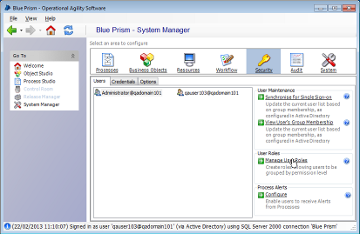
This will open the System Roles dialog.
Select each role one by one from the tree on the left. Enter the corresponding Active Directory group in the text field on the right.
The values you enter here should match the five groups created by your network administrator for the “Create Database” section above. Depending on your network’s Active Directory configuration, you may be able to browse for the corresponding group using the small button to the right of the edit field. Further information is available by clicking “Help”. There is no need to edit the tree on the right.
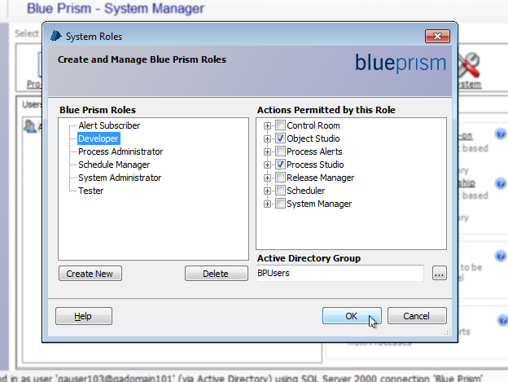
Once complete, click “OK”. Users who belong to the groups entered should now be able to log in to Blue Prism and perform the actions permitted by the corresponding Blue Prism role (as indicated by the tree on the right). Users may have to log out of windows and log back in again for Active Directory changes to take effect.

Configuring the Installation to be a Blue Prism Server
Once Blue Prism is installed it is possible to carry out some additional steps to configure the installation to take on the role of a Blue Prism Server (e.g. the application server through which other Blue Prism installations communicate with the database).
Before configuring any Blue Prism Server instances, any required connections should be configured using the connections form and the Create Database menu option in the Blue Prism client.
It is possible to configure a single Blue Prism installation to act as a number of servers and therefore provide communications to a number of different databases (e.g. it could be both a Development and a Test Blue Prism Server).
This guide talks through how to setup a single installation in the following modes:
- Single Server Mode
- Multiple Server Instance Mode

Single Server Mode
On installation of Blue Prism, a Blue Prism Server service is set up to run a service based on a server configuration named "Default". To configure this server, navigate to the Blue Prism installation directory, typically C:\Program Files\Blue Prism Limited\Blue Prism Automate and open the BPServer.exe program.

Server Overview and Configuration
- To create the default server configuration click the "New..." button.
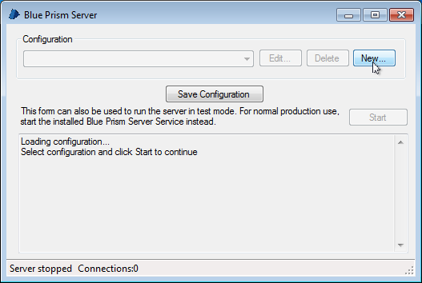
The server configuration will be created and loaded.

- Select the database connection that the server should use. The port can usually be left at the default for a single server, but can be altered if necessary here.
Enter a credentials key if one already exists for this database, or generate a new one - this key is used to encrypt credentials in the Blue Prism Credentials handling.
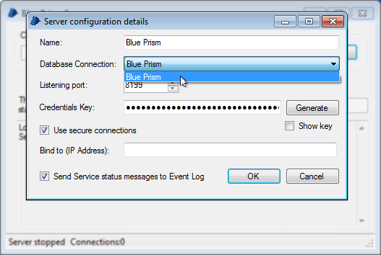
Note: If setting up a failover or replacement Blue Prism Server for an existing database environment then you should specify the same key being used on the existing Blue Prism Server.
If the server is running on a machine with multiple IP addresses, enter the address which the server should listen on for Blue Prism Resource / Client connections.
To have service status messages sent to the Windows Event Log, tick the checkbox at the bottom of the form. When expecting to run the BP Server as a service, this is the only way that diagnostic messages will be recorded, so it is advisable to set it.
When configuration for the individual service is complete, click the "OK" button, then click the "Save Configuration" button to save all server configurations to a file where the service can pick it up from.

Running the Service
Once the configuration is complete, the service can be run by opening the Services Administration Tool in windows (in Administrative Tools in Control Panel), finding "Blue Prism Server", right clicking it and choosing "Start". From here it is possible to make the service start automatically and configure how service failures should be handled.

Multiple Server Instance Mode
Blue Prism can run up multiple servers pointing to different databases. For the sake of example we'll configure 3 services "Blue Prism Dev", "Blue Prism UAT" and "Blue Prism Live".

Assumptions
- As the prerequisites above state, all the connections for the services should be configured in the client before configuring the server.
- For the example, we'll assume the connections are called, simply dev, uat and live.
- The program sc.exe is required - this is the 'service control' program, distributed by Microsoft in their resource kits and with professional editions of their operating systems.
- Administrator access will be required for most of the operations described here.

Remove Default Components
First, the existing default components should be removed - that is the "Blue Prism Server" service installed by default with Blue Prism, and the "Default" server configuration (which may or may not exist, depending on whether it has been run with a single instance or not).
To remove the service, run SC.exe:-
sc delete "Blue Prism Server"
It is also necessary to remove the default server configuration, open BPServer.exe as described in the Single Server Instance above, and press the Delete button to delete the currently selected configuration.

Setup the Server Instances
In the Blue Prism Server window, press the New button. Enter the required name e.g. Dev, the database connection to use.
Note that in order to run multiple server instances, they must, by necessity run on different ports - the example will use ports 8195, 8197 and 8199 for dev, uat and live respectively.
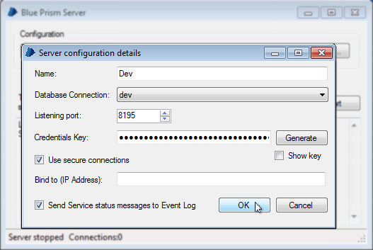
Generate a Credentials Key, and ensure that the Send Service status messages to Event Log checkbox is ticked. Press OK.
Set up the other instances in the same way - i.e. press New, enter the details required for the service and press OK for each required service.
When all the service configurations are complete, click Save Configuration on the overview form to commit the changes.
Note: It is best to leave the configuration name free of spaces or punctuation in order to make the setting up of the services themselves as simple as possible.

Setup the Windows Services
Once the configurations are complete, you can create the services. Again, this uses the service control program:
sc create {SERVICENAME} binPath= "C:\Program Files\Blue Prism Limited\Blue Prism Automate\BPServerService.exe {CONFIGURATIONNAME}"
If Blue Prism is located in a different directory, the path should be altered accordingly
The {SERVICENAME} can be wrapped in quotes if it includes space characters, as shown in the examples.
sc create "Blue Prism Dev" binPath= "C:\Program Files\Blue Prism Limited\Blue Prism Automate\BPServerService.exe Dev"
sc create "Blue Prism UAT" binPath= "C:\Program Files\Blue Prism Limited\Blue Prism Automate\BPServerService.exe UAT"
sc create "Blue Prism Live" binPath= "C:\Program Files\Blue Prism Limited\Blue Prism Automate\BPServerService.exe Live"

Running the Service
Select a service in the Windows Services Console and attempt to start it.
If the service stops immediately, it can indicate a configuration problem - there should be a message in Windows Event Viewer, in the Application log which will hint at the problem.
Some examples:
Bad Configuration Name
Service cannot be started. System.ApplicationException: Invalid arguments
Might suggest that the {CONFIGURATIONNAME} has spaces in it - this is not advisable.
Name Mismatch / Missing Configuration File
Service cannot be started. System.ApplicationException: Server configuration 'Dev' is not defined.
Indicates a name mismatch or a missing configuration file - check the server configuration to ensure the configuration name matches up to that which is defined in the windows service, and ensure that the configuration file is in the correct location:
%ALLUSERSPROFILE%\Application Data\Blue Prism Limited\Automate V3\Automate.config
For Windows 2000, XP, Server 2003
%PROGRAMDATA%\Blue Prism Limited\Automate V3\Automate.config
For Windows Vista / 7 / Server 2008
Other Errors
Service cannot be started. System.ApplicationException: Failed to start server
Further information with a more detailed description can be found in the 'Blue Prism' event log.
Unauthorised Access to the Database
If you get the Failed to start server message and the following message is in the Blue Prism event log:
Connection failed - Unable to determine whether database exists - Login failed for user '{DOMAIN}\{HOSTNAME}$'
This may indicate that windows authentication is being used to log into the database, and the local user (i.e. the user which the service runs as) does not have access permissions on the database. To solve this, the username described in the error message (i.e. "{HOSTNAME}$" where {HOSTNAME} is the name of the computer) must be given the appropriate permissions to the Blue Prism database.

Using the Server
To configure a client, open Blue Prism's Connections Manager by opening the client and choosing Configure Connections at the login page.
Configure a new connection which points to the newly configured server, ensuring that the IP address and port number match those defined in the server configuration.
Save the connection by clicking OK, then open a Blue Prism client and attempt to log into that connection.
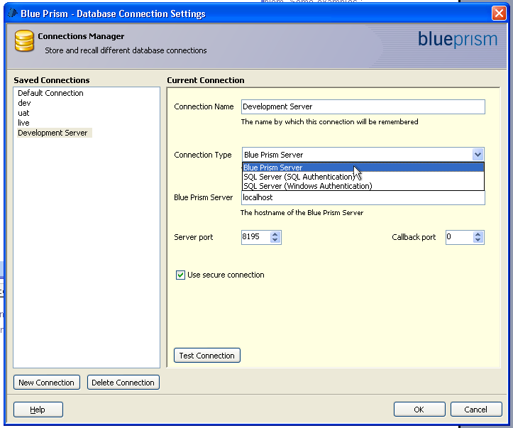

Scripted Installation
It is possible to script the installation of the pre-requisite, supplementary and Blue Prism software. This session provides examples and reference indicators that should help with this.
The examples provided within this chapter are for illustration purposes only and should be thoroughly tested prior to being used in a production environment.

Pre-requisite and Supplementary Software

.Net Framework
To install the .NET Framework, run the following commands:
WindowsInstaller-v2-x86.exe /passive
dotnetfx2.exe /q:a /c:"install" /q
These commands can be safely called even if the respective components are already installed on the machine: each command will gracefully exit without doing any work.

SQL Server
To install SQL Server Express use the comand:
sqlexpr.exe /qb ADDLOCAL=All SECURITYMODE=SQL SAPWD=saPassword
This installs and configures SQL server for mixed mode authentication with a password of saPassword.
The options "SECURITYMODE=SQL" and "SAPWD=saPassword" may be omitted to configure for Windows Authentication only.

Java Access Bridge
To install the JavaAccessBridge use the comand:
accessbridge-2.0.exe /S /v /qn

Blue Prism

Core Application
To install Blue Prism use the command:
MSIEXEC.EXE /I "BluePrism4.0.11.msi" /QB- ALLUSERS=1

Configure the Database Connection
Once the Blue Prism software is installed, the Blue Prism database connection may be configured.
For SQL authentication mode, use:
Automate.exe /setdbname "DB Name" /setdbserver "DB Server" /setdbusername "DB User" /setdbpassword "********"

For windows authentication mode, use:
Automate.exe /setdbname "DB Name" /setdbserver "DB Server"

Create a Blue Prism Database
Once a database connection has been defined a Blue Prism Database can then be created.
Native Blue Prism Authentication
AutomateC.exe /createdb "*******"
The password is only required if SQL Authentication is being used to connect to the database server. In the above example the AutomateC.exe executable is being used rather than Automate.exe.
Active Directory Authentication
AutomateC.exe /createdb "*******" /setaddomain "Domain Name" /setadadmingroup "Group Name"
The password specified after /created only needs to be supplied if SQL Authentication is being used to connect to the database server.
The current user must belong to the AD Group specified as the /setadmingroup.
It is also necessary for a manual step to be carried out: you must sign in and configure the Single Sign-on Groups. Instructions are provided within the SQL Database Guide in the Appendix which contains a chapter on .

Register the License Key
Version 4.2.15 and Earlier
The Blue Prism license key can be set using the command:
AutomateC.exe /license "Owner" "keyABCDEFG12345678"
Both the Owner and Key need to be set with the relevant information from the License.
Version 4.2.16 and Later
From version 4.2.16 the license key is contained within a file.
can be set using the command:
AutomateC.exe /license “Path of License File”

Import Processes
If there are a Business Objects or Processes to be imported the xml files can be imported individually using the command(s):
AutomateC.exe /import "C:\My Process.xml" /user admin admin
AutomateC.exe /import "C:\My Object.xml" /user admin admin
The user credentials supplied here (username "admin" and password "admin") are the sample options for native authentication; these have not yet been changed but will be changed later. Where Active Directory authentication is being used, the option "/user admin admin" should be replaced with "/sso"; this assumes that the Active Directory groups have already been configured.

Publishing Processes
Any processes which need to be published can be published as follows:
AutomateC.exe /publish "My Process" /user admin admin
Publishing a process makes it available to be run or scheduled.

Scripting References
The following table provides references to further information on the command line examples printed above.
Topic | Help Reference | Download Location
.NET Framework Redistributable | http://www.microsoft.com/downloads/details.aspx?FamilyID=0856eacb-4362-4b0d-8edd-aab15c5e04f5&displaylang=en | http://www.microsoft.com/downloads/details.aspx?FamilyID=0856eacb-4362-4b0d-8edd-aab15c5e04f5&displaylang=en
msiexec | http://technet.microsoft.com/en-us/library/cc759262%28WS.10%29.aspx | N/A
SQL Express 2005 | http://msdn.microsoft.com/en-us/library/ms144259%28SQL.90%29.aspx | http://www.microsoft.com/downloads/details.aspx?familyid=220549b5-0b07-4448-8848-dcc397514b41&displaylang=en
Blue Prism | AutomateC.exe /help  or  Contact your Account Manager or the Technical Support Team | N/A

Appendix

Supported Software
The following technologies are supported for use with the software.

Operating System
Version | Blue Prism Client | Blue Prism Server
Windows XP (SP2+) | ✓ | ✓
Windows Vista x86 (32-bit) | ✓ | ✓
Windows Vista x64 (64-bit) | ✓* | ✓
Windows 7 x86 (32-bit) | ✓ | ✓
Windows 7 x64 (64-bit) | ✓* | ✓
Windows 8 x86 (32-bit) | ✓ | ✓
Windows 8 x64 (64-bit) | ✓ | ✓
Windows Server 2000 (SP4) | ✓ | ✓
Windows Server 2003 (SP1) | ✓ | ✓
Windows Server 2008 R2 x64 | ✓* | ✓
*Where the Blue Prism client is installed on a 64-bit operating system, it will run as a 32-bit application.
✓ = Supported
✓ = Supported but still undergoing testing
64-bit application integration using invasive techniques is not supported.

Microsoft SQL Server
The following Microsoft SQL Server versions are supported for locating the Blue Prism database.
 | Express | Standard | Enterprise
SQL 2005 | ✓ | ✓ | ✓
SQL 2008 &  SQL 2008 R2 | ✓ | ✓ | ✓
SQL 2012 | ✓ | ✓ | ✓
Both x86 (32-bit) and x64 (64-bit) are supported.
SQL Express versions are only appropriate for non-production environments such as for the purposes of Proof of Concept exercises.

Microsoft .Net Framework
To install Blue Prism a minimum version of Microsoft .Net Framework 2 is required.
Applications built on the following .Net Framework Versions are supported for the purposes of interacting with Blue Prism:
- 2.0
- 3.0
- 3.5
- 4.0
See the chapter on Verifying the .Net Framework Version(s) Installed for additional guidance.

Web Browser
Where Blue Prism is required to interact with Web Applications, the following browsers are supported:
- Internet Explorer 6
- Internet Explorer 7
- Internet Explorer 8
- Internet Explorer 9
- Internet Explorer 10
- Internet Explorer 11
Currently only x86 (32-bit) versions of Internet Explorer are supported.

Java Access Bridge (JAB) and Runtime Environments (JRE)
Blue Prism supports JAB version 2.0.0 for use with JRE version 1.2.2 and above.
JAB 2.0.0 does not support 64-bit Java, so for 64-bit OS machines, please ensure you have 32-bit Java installed.

Verifying Software Versions

Verifying the Blue Prism Version
The Blue Prism version information can be found within the application under Help -> About.
 | 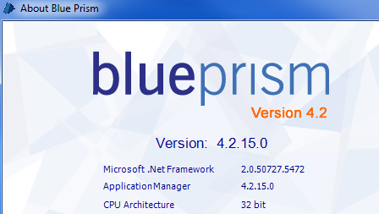

Verifying the .Net Framework Version(s)
It is possible that more than one .Net Framework version may be installed as some versions do not necessarily supersede earlier releases.
The installed version(s) can typically be viewed from within the Programs list accessed via Control Panel.
If you are using Windows 7, the Programs list is called Programs and Features.
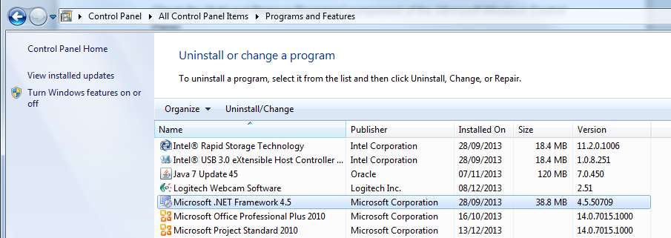

SQL Database Guide
The following sections provide step by step guides to help carry out common database related tasks for Blue Prism.

Configuring SQL to accept Remote Connections
Where the SQL Server is installed on a separate server to the Blue Prism installation, it is important to ensure that the SQL Server is able to accept Remote Connections. In many default installs of SQL 2008 R2 or later, Remote Connectivity is disable by default.
Typically enabling Remote Connectivity is done for a given SQL Server Instance and therefore affects all databases within that Instance.
The links below are to articles published by Microsoft on this topic.
Enable the TCP/IP Protocol for a Database Instance (2005, 2008)
Enable the TCIP/IP Network Protocol for SQL Server (2012)
Additionally it is important that the SQL Browser Server is started on the applicable SQL Servers. This is particularly important for SQL Server Express editions where the service is disabled by default.

Configuring a Connection to the Database
This guide provides step by step instructions to set up the database connection information for the SQL Server within Blue Prism.
If any issues are experienced whilst following these instructions please refer to the section on Troubleshooting an Installation in this document.
- Start Blue Prism from the Windows start menu or desktop.
- When you open Blue Prism on a computer for the first time, a message appears indicating that you must “specify a database connection before Blue Prism can function”.
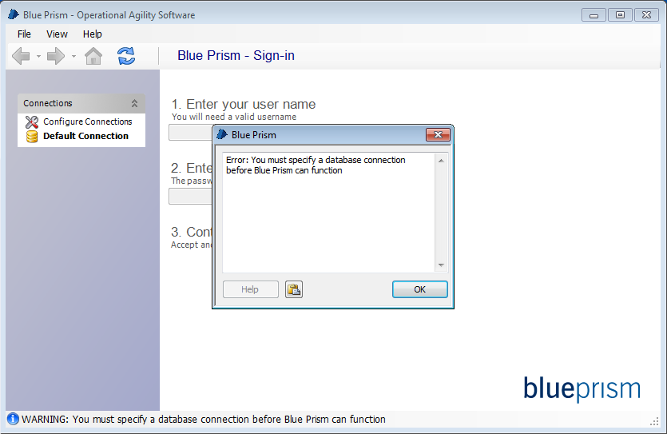
- Chose Configure Connections from the Connections table on the left of the window. This will launch the wizard that can be used to provide the connection information. 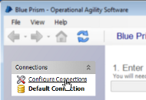
  - If you are using Windows Vista or later and User Account Control is enabled it may be necessary to enter elevation mode and additional pc or network credentials may be required.
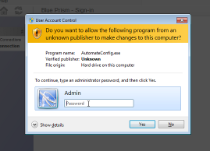
- The Connection Configuration window should now be displayed.
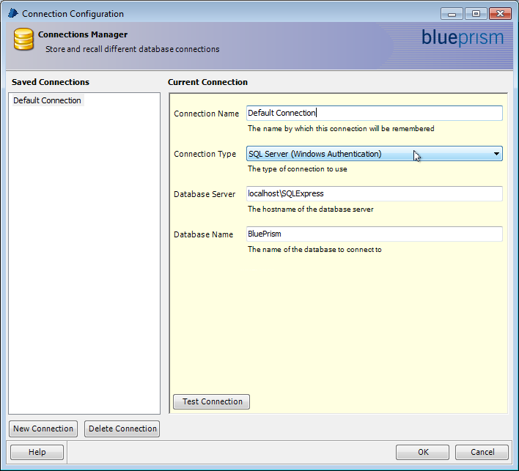
The connection information for the database server and target database should be entered here.
Connection Types
The following definitions provide more information on each of the options for Connection Types:
- SQL Server (SQL Authentication)
Connect to a named SQL Server instance using a saved User ID and password.
- SQL Server (Windows Authentication)
Connect to a named SQL Server instance using windows authentication. Note that database rules governing security must be implemented on the database for the currently logged in user or user's group.
- Blue Prism Server
Connect to a named host and port which is running a Blue Prism Server instance. Further guidance regarding Blue Prism Server is given later in this document and in the Help file distributed with the product.
- Press 'OK' to save the data and return to the Blue Prism client.
- An expected error message will be presented if the database cannot be found – this is only expected in situations where the target database does not yet exist (e.g. where Blue Prism is being set up for the first time).
If you are setting up a connection to an existing database or to an existing Blue Prism Server any error message presented here indicates that there is some communication problem between the client and SQL Server.
- Press OK to dismiss the message.

Creating a Database
Within the Blue Prism application, click the File menu and select Create Database.
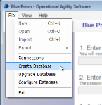 | 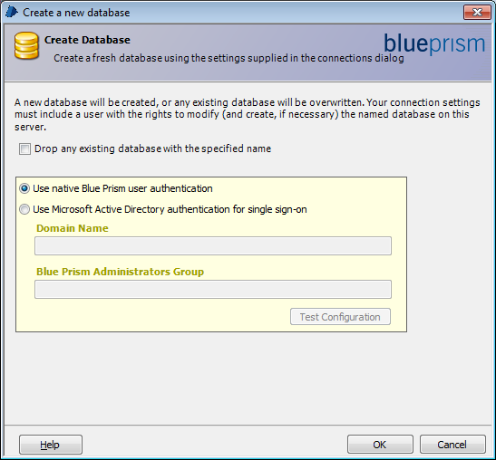
There are two options for SQL user authentication and this cannot be changed once the database has been created.
- Native Authentication
Preferred for simple or small-scale installations. User accounts are stored and managed in the Blue Prism database. User accounts must be created individually for users (or shared as a generic login) within Blue Prism. There is no relationship with the current operating system user and, beyond a database / BP Server instance, there are no further external dependencies for this option.
- Microsoft Active Directory authentication for single sign-on
Designed for large organizations with centralised control over users and resources. There is no need for user management within Blue Prism: this is all handled centrally in Active Directory. Users are authenticated to use Blue Prism according to their operating system user credentials (provided they belong to the relevant groups), and enjoy the convenience of automatic sign-in as a result.

Native Authentication
If Native user authentication is selected it is necessary to enter the database credentials to allow the database to be created.
Once the credentials are provided, clicking OK will create the database.

Active Directory Authentication
If Active Directory authentication is selected it is necessary to provide both the name of the Active Directory domain and the name of the a pre-existing user security group that will be used as the container for Blue Prism administrators is required.
To use Microsoft’s Active Directory for Blue Prism user authentication:
- Select the “Use Microsoft Active Directory authentication for single sign-on” radio button
- Enter the name of the domain in which the Active Directory instance is operating.
- Enter the name of the Active Directory group which contains the users who will act as Blue Prism Administrators.
- Click the Test Configuration button and address any errors that are raised, if any.
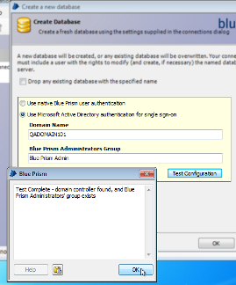
The permissions in Blue Prism can be grouped into 'roles'. Each role can be mapped directly onto an Active Directory group, so further groups will need to be created and populated to allow for fully centralised control of Blue Prism user access.

Updating the License Key
Apply the license key using the instructions below based on the version of the software that is installed.
The changes will be effective immediately after the license has been successfully updated.
All Blue Prism components on each Interactive Client, Resource and Server will need to be restarted for the changes to be fully recognised.

Version 4.2.15 and Earlier
To install or update a Blue Prism license key follow the steps below:
- Launch Blue Prism.  - Click System Manager.  - Click the System menu item.  - Click the License tab.  - Enter the license details including the License Owner and License Key. | 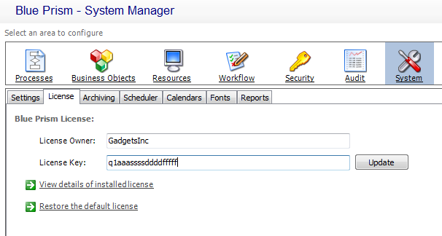

Version 4.2.16 and Later
To install or update a Blue Prism license key follow the steps below:
- Launch Blue Prism.  - Click System Manager.  - Click the System menu item.  - Click the License tab.  - Select Install new licence.  - Select the License file and click OK. | 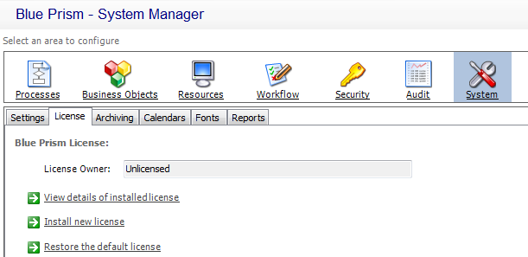

Verify an Installation
This section provides a simple automation scenario in order to test the install has been successful. It should be noted that successfully completing this verification confirms that the basic components of the Blue Prism installation are operating as expected.
The verification steps include:
- Creating a new Process using the Microsoft Word Object
To verify an installation using this section the Microsoft Word Object must be installed (as per the instructions on how to Import the Microsoft Word Object).
- Test the Process
If the installation of Blue Prism is against an existing database it will be necessary to carry out this test using unique process names and it is not possible to have two processes within the same database with the same name.
If problems are experienced whilst verifying the installation, in the first instance the section on Troubleshooting an Installation should be reviewed.

Create a new Process
- Click Process Studio from the left-hand navigation menu.
- Click Create a new Process on the resulting screen. A wizard will pop up.
- Enter the name Letter Writing Test for the new process.
- Enter the description Evaluation test.
- Process Studio will now appear.
- From the toolbar at the top chose the Action stage tool as illustrated.
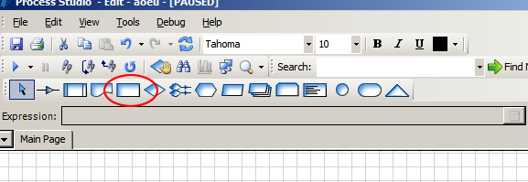

- Place four action stages vertically on the diagram, equally spaced between the start and end stages.
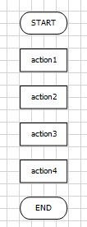
- Double click the first stage (or right-click and choose “properties”). A properties form will appear.
Enter the name Create new Document at the top, and from the combo boxes below, choose the combination MS Word VBO and Create Document.
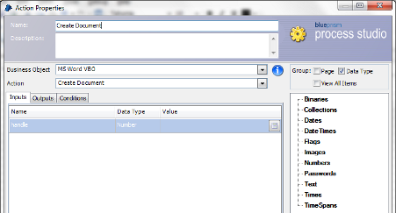
The inputs may be left blank.
- Click OK to save your changes and exit the form.

- Repeat the same steps for each for the remaining three stages using the names and actions as identified in the table below.
Original Name | New Name | Business Object | Action | 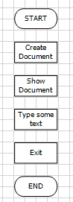
action2 | Show Document | MS Word VBO | Show
action3 | Type some text | MS Word VBO | Type Text
action4 | Exit | MS Word VBO | Exit
- Double click the stage named Type some text to edit the properties.
- Within the Value column of the Input parameter called text, enter a short sentence which will be entered into the word document when the process runs.
The sentence will need to be within double quotation marks.
E.g. “This is some text”
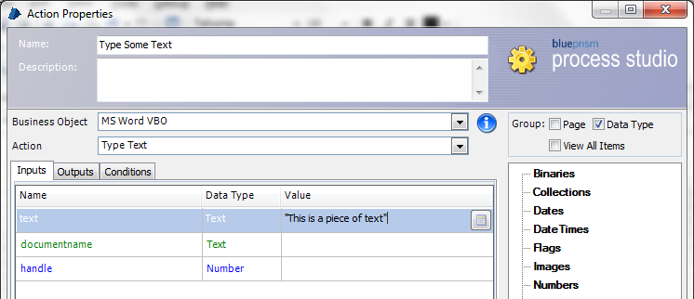

- Click OK to return to Process Studio.

- From the toolbar select the Link tool and use the mouse to link each of the stages in turn by dragging from one stage to the next.
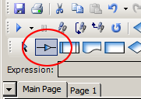  Link tool | 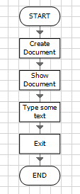
- Save the process from the File menu – a confirmation message should be displayed in the status bar at the bottom of the window.

Test the Process
To test the process we will need two buttons from within the toolbar of Process Studio:
- Step  Highlighted on the left  - Reset  Highlighted on the right | 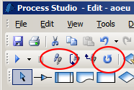
- Once the process has been saved, click the Reset button.
- Click the Step button in the toolbar. This should cause the first stage in the process diagram to highlighted in orange and indicates that this is the next stage to be run. Next time Step is pressed the actions within that stage will be performed.
- Click Step again and this will cause the actions in the first stage to be performed (e.g. a new Microsoft Word document will be created although at this time it is not yet visible to the user).
- Continue to click Step to progress from the stage to stage.
Verify that the expected action takes place with each step (i.e. the new Microsoft Word document is shown, the correct text is typed into the document, and the document disappears on “Exit”).
- If you wish to run the process again, click the “reset” button and repeat.

Troubleshooting an Installation
The following sections seek to provide guidance if specific issues are experienced either during the install or when verifying that the installation has been successful.

Cannot connect to [SQL Server]
Assuming that network connectivity is in place there are a number things to check where a connection to SQL Server over the network.
- SQL Credentials
Verify the SQL Credentials and that the user has appropriate permissions on the SQL Server.
- Firewall
Firewalls on the servers themselves or within the network may be preventing communication.
- SQL Browser Service
The SQL Browser Service on the SQL Server will need to be enabled to allow for a SQL Instance to be found. For SQL Server Express this service is typically disabled by default.
- Enabling TCP/IP Connectivity
Where remote connectivity is required to SQL, TCP/IP connectivity will need to be enabled for the SQL Instance. For guidance on enabling this connectivity see the chapter on Configuring SQL to accept Remote Connections with in SQL Database Guide.

Unable to determine whether database exists
When testing a SQL connection an error message is displayed:
Unable to determine whether database exists - A network-related or instance-specific error occurred while establishing a connection to SQL Server. The server was not found or was not accessible. Verify that the instance name is correct and that SQL Server is configured to allow remote connections. (provider: SQL Network Interfaces, error:26 - Error Locating Server/Instance Specified)
This is a common error when working with SQL 2008 R2 or later as the server is set up by default to no accept remote connections. TCP/IP connectivity needs to be enabled for the given instance of SQL Server.
For guidance on enabling this connectivity see the chapter on Configuring SQL to accept Remote Connections within the SQL Database Guide in this document.

Failed to create Database – A network-related…
When creating a SQL database through Blue Prism an error message is displayed:
Failed to create database – A network-related or instance-specific error occurred while establishing a connection to SQL server. The server was not found or was not accessible. Verify that the instance name is correct and that SQL Server is configured to allow remote connections. (provider: Named Pipes Provider, error: 40 – Could not open a connection to SQL Server)
This is a common error when working with SQL 2008 R2 or later as the server is set up by default to no accept remote connections. TCP/IP connectivity needs to be enabled for the given instance of SQL Server.
For guidance on enabling this connectivity see the chapter on Configuring SQL to accept Remote Connections within the SQL Database Guide in this document.

Error Message 2869 on installation
If, when installing over an earlier version of Blue Prism, an error message is displayed with an Error Code 2869, the earlier version should be uninstalled first. If, when attempting to do this, an empty error message box is displayed and the uninstall fails, the earlier version may have been corrupted by the aborted installation.
To fix this, enter the Add/Remove Programs applet in Control Panel, and Repair the Blue Prism installation. Attempting to uninstall Blue Prism should now work correctly, and the new version can be installed normally.

Insufficient Permissions error message is displayed
A message is displayed:
CREATE DATABASE permission denied in database 'master'
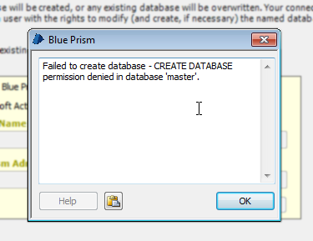
This indicates that the SQL user does not have permission to create a new database. This typically happens with Windows Authentication, but may occur with a SQL authenticated user with restricted power. A number of options are available for working around this issue:
Giving the user the CREATE DATABASE permission in the SQL Server instance
Configuring the connection to use a different login with the CREATE DATABASE permission
Running Blue Prism as administrator may be enough to fix it. This only works if the Administrators group is given the dbcreate role in the SQL Server instance - something which occurs by default in SQL Server Express 2005, but not in later versions. To do this, find the Blue Prism executable, right-click it and choose Run as administrator. The executable is typically found at:
C:\Program Files\Blue Prism Limited\Blue Prism Automate\Automate.exe
Asking a DBA to create the database. The database can be populated by the Blue Prism client using the Create Database command which will fill in the database with the Blue Prism tables.

Unhandled Exception entering System Manager in Windows Server
After installing on Windows Server, entering System Manager generates the exception:
System.TypeInitializationException: The type initializer for 'BluePrism.AutomateLicensing.clsLicensingRuntime' threw an exception. ---> System.InvalidOperationException: This implementation is not part of the Windows Platform FIPS validated cryptographic algorithms.
at System.Security.Cryptography.MD5CryptoServiceProvider..ctor()
at BluePrism.AutomateLicensing.AuthorisationDetails.GetCheckSum()
at BluePrism.AutomateLicensing.AuthorisationDetails.FromLicenseKey(String A)
at BluePrism.AutomateLicensing.clsLicensingRuntime..cctor()
In order for the encryption used in the Blue Prism license to work correctly, the Enforce FIPS policy within Windows must be disabled. This can be done by disabling the setting within the local/group policy:
System cryptography: Use FIPS 140 compliant cryptographic algorithms, including encryption, hashing and signing algorithms
If this is not possible, a workaround is available to fix this within Blue Prism only. Create an XML file with the contents as below and copy it into the Blue Prism installation directory. It will need to be copied several times to affect all of the Blue Prism executable files. It should be saved with the following filenames :-
- Automate.exe.config
- AutomateC.exe.config
- BPServer.exe.config
- BPServerService.exe.config
On running the application, System Manager should be available once more.
XML File Contents
<configuration>
<runtime>
<enforceFIPSPolicy enabled="false"/>
</runtime>
</configuration>

